**PYTHON PT3**

|  |  |
| --- | --- |
| HARSH SHARMA | 2K18CSUN01145 |
| Btech-CSE4A | PT3 |

**Theory Questions**

**Q1. What is the syntax to call a constructor of a base class from child class?**

**Ans: By using super class**

**Q2. How is class made as inherited class (syntax of child class)?**

**Ans: class Parent:**

**pass**

**class Child(Parent):**

**pass**

**Here the class child inherits the class parent**

**Q3. Print an element of a nested dictionary?**

**Ans: people = {1: {'name': 'John', 'age': '27', 'sex': 'Male'},**

**2: {'name': 'Marie', 'age': '22', 'sex': 'Female'}}**

**print(people)**

**PRACTICAL QUESTION**

**SET B**

**Q1. Write a program that accepts a sequence of whitespace separated words as input and prints the words after removing all duplicate words?**

**Ans:**

**phrase = input("\tENTER THE SENTENCE:\t ")**

**phrase_splited = phrase.split(' ')**

**word_list = []**

**for i in phrase_splited:**

**if i not in word_list:**

**word_list.append(i)**

**else:**

**continue**

**word_list.sort()**

**print((' ').join(word_list))**

**OUTPUT:**

**ENTER THE SENTENCE: HARSH SHARMA SHARMA IS IS A PROFESSIONAL CHOREOGRAPHER AND A ACTOR ACTOR**

**HARSH SHARMA SHARMA IS IS A PROFESSIONAL CHOREOGRAPHER AND A ACTOR ACTOR**

**A ACTOR AND CHOREOGRAPHER HARSH IS PROFESSIONAL SHARMA**

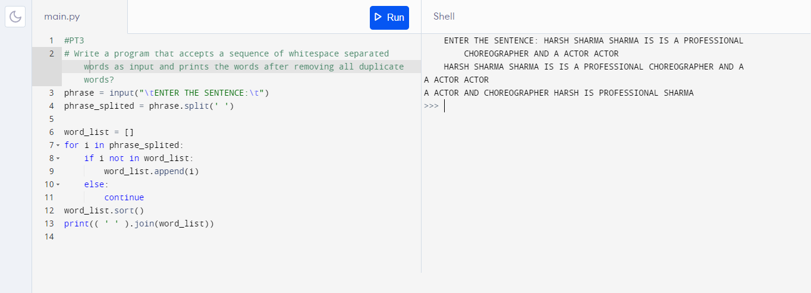

**Q2.By using list comprehension, please write a program to print the list after removing the value 24 in [12,24,35,24,88,120,155]?**

**Ans:**

**list1 = [12,24,35,24,88,120,155]**

**list1 = [ elem for elem in list1 if elem != 24]**

**print(“NEW LIST IS”,*list1)**

**OUTPUT: NEW LIST IS 12 35 88 120 155**

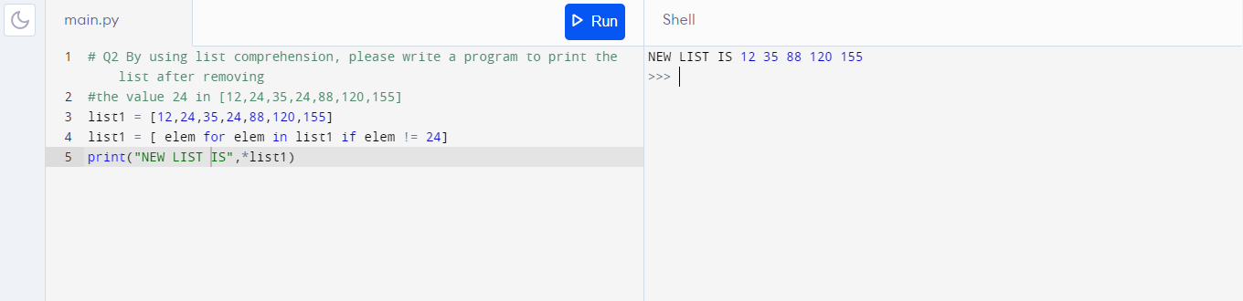

|  |  |
| --- | --- |
| **HARSH SHARMA** | **2K18CSUN01145** |
| **Btech-CSE 4A** | **PT3** |